***Directions: Provide a snippet of each figure in the tutorials below.***

**Tutorial 9-1 (Pg. 578):**

1. Figure 9-5:

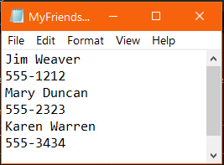

**Tutorial 9-2 (pg. 583):**

1. Figure 9-10:

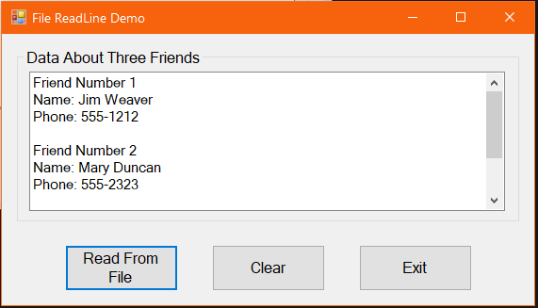

**Tutorial 9-3 (pg. 587):**

1. Figure 9-14:

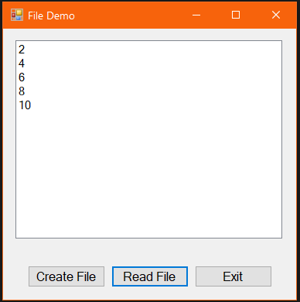

***Continuation of Snippets:***

**Tutorial 9-4 (pg. 597):**

1. Figure 9-21:

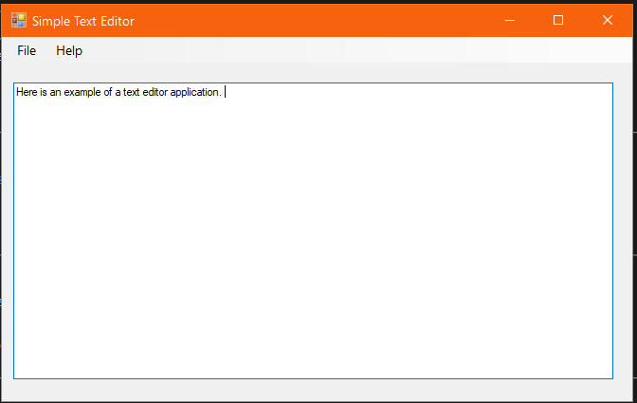

**Tutorial 9-5 (pg. 608):**

1. Provide a snippet of the code and the interface after Step 6:

